**Setnor School of Music Operations Handbook**

**Your first priorities as a student of the Setnor School of Music at Syracuse University are your wellness and your studies. While being a work-study student in music is an important obligation, it cannot interfere with your studies or your well-being.**

The safety and comfort of the students, faculty, and staff is of critical importance. Please refer to [**Stay Safe - Syracuse.edu**](https://www.syracuse.edu/staysafe/) and the [Orange Safe Ap](https://dps.syr.edu/services-resources/orange-safe-app/?_gl=1*uptmm1*_gcl_au*MjA2OTk5MTAzNS4xNzQxMTAzOTQz*_ga*ODQ0MzA4NDUwLjE2NzAyNTIwODU.*_ga_JYZJL3F4BE*czE3NDc3NjQ3OTEkbzEwMiRnMSR0MTc0Nzc2NDg0NyRqNCRsMCRoMCRkWU8tZzJoSVR6U0ctVWR2dHk3WUNBRU80R3pTQXRuSDYzQQ..*_ga_QT13NN6N9S*czE3NDc3NjQ3OTEkbzgxNCRnMSR0MTc0Nzc2NDg0NyRqNCRsMCRoMCRkUHh0cWhndU1ZeE1oV0cwemxwSUtmS25USlhpTkVvMGVKQQ..) for up-to-date campus guidelines and information.

The Setnor School of Music work-study staff is comprised of students who work as recording studio staff, office staff, and for performances and other events. This handbook outlines the general responsibilities and guidelines for this work - if you have any questions about specific work or expectations, it is your responsibility to ask for more information. We expect you to review the handbook and understand your responsibilities. We hope you will find working in the school a great learning experience and enjoyable work opportunity.

In receiving this handbook and starting your position, consider this an agreement - if at any time, you or we feel you cannot meet these responsibilities, we will talk about taking a break or discuss ending your employment. This employment is not a guarantee; there are times when the student or the office will find that this is not the right fit, and that a resignation or dismissal is in order. Grounds for dismissal include, but are not limited to:

* Failure to comply with campus rules, regulations, and any guidelines in the handbook or from supervisors
* Two absences without notification or replacement or instances of showing up late for a performance
* Giving out a codes, combinations, or other information or access that is restricted to employees
* Sharing confidential information
* Failure to act in a professional, kind, and respectful manner
* If there is a need to speak with you about your performance and that discussion does not result in immediate, lasting, and significant improvement

**Payroll**

Work-study is a federal grant you must currently be eligible for to work in this office. If you do not have confirmation that you have a work-study grant, please be reminded that we can only hire students with work-study. You can find out more information through the financial aid office.

**Electronic TimeClock:** You are responsible to clock in and out for work in order to be properly compensated.

1. Log into Myslice using your NetID and Password.
2. In the box labeled “*Other Employee Services,*” click “*Employee TimeClock Login.*”
3. The TimeClock system will require you to do a NetID login again (at least the first time).
4. In the top left of the site, click “*Clock In*” when you begin your work for 301 in any capacity (Office Hours, Performance Management, Programs, Posters, Social Media, and other approved projects).
5. When your work is completed, click the “*Clock Out”* located next to the “*Clock In”* function.

If you forget to clock in or out, reach out to [Michelle](mailto:mjtaylor@syr.edu) Taylor immediately to avoid delays in processing your hours.

**Working events**

Professionalism is critical to the work at the school. At times, you will observe or be part of conversations that may be sensitive and require discretion. We expect everyone to represent the school with a high level of professionalism and not to make comments about performances, guests, etc. Any failure to adhere to a strict policy of care, discretion, and kindness will result in the immediate loss of this position.

The work at the school can be time sensitive, and the students, faculty, and staff rely on the support our work provides. Attendance, timeliness, and adherence to the policies in this handbook and following directions from supervisors are critical. It is critical that those working are on time, prepared for the activities, and ready to work – if you are late or do not show up, this is grounds for losing your position.

You must wear safe and appropriate footwear for moving large items – no exceptions! It is important to be safe, and also to look professional and not stand out during performances – for working on stage during events, please wear black that is professional but comfortable enough to move equipment. There are events at which Syracuse gear or casual dress is appropriate (such as convos or weekday meetings).

**Care of Equipment**

You will be working with university equipment that is necessary for classes, rehearsals, events, and recording. Great care should be taken of all equipment - many items are difficult to repair or replace and are important for the performances and classes. If you feel you need additional training to handle equipment properly, please speak with your supervisor.

* Check with your supervisor on proper use, moving, and storage of equipment.
* Equipment is sensitive, and most requires specific methods and materials for cleaning. NEVER clean a piece of equipment without confirming the process.
* **VERY IMPORTANT: if an item breaks, let us know right away so no one uses something that is unsafe!**

In the case that equipment is damaged or not working, please inform a supervisor immediately so it can be addressed right away. We do not want someone expecting to use a piece of equipment to find it not working. We understand that equipment can fail and break, but failure to report something not working may result in injury and will be taken most seriously.

* For issues with recording studio equipment, notify Professor Muldoon immediately.
* For issues with percussion, notify Michelle so she can let percussion faculty know
* For issues with a studio or classroom, contact Michelle Taylor at [mjtaylor@syr.edu](mailto:mjtaylor@syr.edu) or 315-443-9691.
* For piano concerns, text Bob Lee or notify Michelle or Bryan.
* For immediate concerns like a water leak or electrical problem, call Physical Plant immediately at 315-443-1234 and notify Michelle so she can follow up.
* Wash hands thoroughly or use hand sanitizer before and after handling items.

**Pianos**

* Care of the pianos is extremely important.
* If you move a piano for a class, be sure to put it back in place and plug the system back in!!
* Do not place any items on or in pianos and remove items if you see any on an instrument.
* Inform the Piano Technician, Bob Lee (315-671-6560), immediately of any problems with pianos.
* If you will be moving the auditorium pianos in your assignment, you must meet with Bob to train for proper moving of the pianos.
* For piano keys, only use isopropyl alcohol 60-70% wipes (this dries extremely quickly). DO NOT USE wipes on any other part of the piano. They will be monitored and disinfected by the piano technician.
* Wash hands thoroughly or use hand sanitizer before and after handling items.

**Security**

**For DPS, dial 315-443-2224 or #78 from a cell or 711 from a campus phone**

**For a DPS Safety Escort, call 315-443-SAFE**

**If you need to contact DPS in an emergency situation, but are unable to make a phone call, e-mail or text the Communications Center at** [**711@syr.edu**](mailto:711@syr.edu)**.**

**Your safety is very important. Call Department of Public Safety, 315-443-2224, if you need assistance, or any time there is a security concern.** The following items are a portion of the University’s Safety Plan and have been reviewed for Crouse College activities by Fire and Life Safety Services.

**In the event of a building evacuation, please instruct the class, co-workers, or guests on the QUAD parking lot side of the building, where there is generally safe space to meet, account for personnel, and safely wait or depart the area.**

**Medical Emergency**

* In any emergency, contact the Department of Public Safety at 711 from campus phone, dial #78 from a cell phone, or 315-443-2224 from any phone.
* Do not attempt to move the person. Assist by trying to retrieve helpful information for public safety, such as the name and concern of the person. Notify the first responding of location of injured person.
* Assist by keeping others away from incident so public safety has easy access. Remain calm. Try to keep others calm.

**Fire & Smoke Evacuation Procedures:** *If a fire alarm sounds, take it seriously. If you notice a fire or smell smoke:*

* DO NOT attempt to fight the fire.
* Call the Department of Public Safety at 315-443-2224 or 711. Give your name, the name of the building, exact location and type of problem. Pull the fire alarm box located next to any stairwell.
* Exit the building using stairwells.  Never use the elevators. Close and secure all doors behind you.
* Proceed to the designated meeting area(s). For Setnor, this is the Quad parking lot on that side of the building, or the bottom of the steps if exiting on that side of the building. Keep quiet and listen for directions from Fire and Life Safety Services, the Department of Public Safety, or the fire department.
* Notify first responders of trapped or injured persons or persons with disabilities and their location(s) and/or communicate to the Department of Public Safety at 315-443-2224 or ext 711.
* **Never** re-enter the building unless directed to do so by Fire and Life Safety Services, the Department of Public Safety, or the fire department.

**General Evacuation Procedures:** *The following procedures apply to any evacuation situation:*

* Become familiar with the building. Know the location of emergency exits.
* In any emergency, contact the Department of Public Safety at 315-443-2224 or 711.
* In the event an evacuation is necessary, you will be directed by the Fire and Life Safety Services, the Department of Public Safety, the fire department, or building coordinators to evacuate.
* Remain calm. Try to keep others calm.
* Exit the building using stairwells. Direct audience and artists to the nearest exit. Never use the elevators. Close and secure all doors behind you.
* Proceed to the designated meeting area(s). For Setnor, this is the Q-1 parking lot on that side of the building, or the bottom of the steps if exiting on that side of the building. Keep quiet and listen for directions from Fire and Life Safety Services, the Department of Public Safety, or the fire department.
* Notify the first responding agency of trapped or injured persons or persons with disabilities and their locations.
* **Never** re-enter the building unless directed to do so by Fire and Life Safety Services, the Department of Public Safety, or the fire department.

In the unlikely event that the auditorium or building needs to evacuate, or DPS / Orange Alert has issued directions, here is some sample language. An ensemble director may announce this, if available, but the performance manager on duty should be prepared to provide the information to the audience and performers.

**EVACUATION:** *We have been advised of a safety concern in the building and have been asked by DPS to evacuate the building. Please proceed to exits and calmly exit the building and await further information from DPS. Thank you.*

**SHELTER IN PLACE:** *We have been advised of a security issue on campus and have been asked by DPS to remain in the auditorium. Please remain calm and quiet and silence devices as we wait for further instructions from DPS. Thank you.*

**Disruptive Patron / Intruder Situation:** *It is important that you are safe. Do not approach someone causing a safety concern.* **Call DPS 315-443-2224 for assistance, or any time there is a security concern**.

* If a patron causes a disruption during an event or is not complying with school or campus polices, please remind them and/or advise them to be quiet to respect the performance. If they do not comply, please call DPS (department of public safety) to assist.
* If a patron does not leave after a concert, please let them know that they are welcome to return for the next concert, but that we need to clear the auditorium in preparation for the next event. If they do not comply, DPS can be called to assist with either talking to or ejecting the patron.
* If someone enters the building who is unknown and does not seem to be there to attend an event and/or you are not comfortable, contact public safety.

**Security Guidelines for Room Usage:** Lock rooms when you leave, even if you plan to return shortly. Do not leave unattended valuables, or store instruments or other personal items in public practice rooms. Please contact the University’s Department of Public Safety (DPS) immediately if you are concerned about safety. For more information, visit the DPS website at <http://publicsafety.syr.edu/>

**DPS** 315-443-2224 if there are security/safety concerns

**PHYSICAL PLANT** 315-443-1234 if there is a maintenance issue

**AUDIO** 315-443-4107 if there is an audio problem. 315-730-1982 (Kevin Muldoon cell)

**OPERATIONS** 680-877-5033 (Michelle cell), 315-450-0639 (Bryan cell)

**Recording studio**

Setnor School events take place in Setnor Auditorium, Hendricks Chapel, Shemin Auditorium, and select locations around campus. You will be responsible for setting up the audio needs for the performance and recording.

**Schedule:** Work with Professor Muldoon on scheduling. Please note that failure to show up for scheduled events or neglecting to sign up for shifts will result in removal from the staff. **It is critical that all performance shifts are covered. If you cannot work, YOU** must arrange for a replacement if you have signed up to work an event and find you are unable to work.

Direct instructions for your work will be provided by Professor Muldoon. Duties include but are not limited to these items:

* set up for any audio needs in the school, including live sound for meetings and performances, live streaming, archival recording, etc.
* be able to move equipment and to set sound and gear for a variety of types of performances
* be friendly and helpful to performers and colleagues. Work well with others—this is essential as it is all very cooperative work. Maintain a friendly and helpful attitude, and be a problem solver
* speak knowledgably and respectfully to in-house and guest artists and ensembles about their needs and preferences for performance

**Performance Manager**

Setnor School events take place in Setnor Auditorium, Hendricks Chapel, Shemin Auditorium, and select locations around campus. You will be responsible for setting up for the performance, assisting the performer with anything they need, and facilitating guests.

**Schedule:** The manager will open the month up for signing up for performance duty. You will receive notice advising everyone to sign up for concerts that month. It is mandatory that all employees sign up for the specified number of shows each semester to hold their position. This number will change each semester/time frame according to the number of shows in total. Expect at least 2-5 mandatory shows per month, depending on number of shows each month. Once this has taken place, everyone will receive another notice that shows are open for further sign up. You cannot remove your name once you have signed up until you confirm your replacement.

**It is critical that all performance shifts are covered. If you cannot work, YOU must arrange for a replacement if you have signed up to work an event and find you are unable to work. You must reach out to individuals and confirm a replacement– a note to colleagues or on the Facebook page is not sufficient. Failure to show up or find a replacement on two occasions within the academic year for concerts, for ANY REASON will result in a loss of your position. Unless it is an emergency, get in touch with colleagues to find a replacement before contacting office staff.**

**Once you have a confirmed replacement, you and your replacement can adjust the names in the google calendar, so the office staff knows who will be working the show.**

**Office Assistant**

The office must have a welcoming and enjoyable atmosphere, but it is most importantly a place of work for all of us. We must all work responsibly and with a high level of politeness and professionalism, while keeping health and safety protocols in mind. There are several responsibilities when working in the office – students, faculty, and staff to assist, mail to be sorted, programs to be processed, concert preparations, classroom and rehearsal set ups, cleaning, and other tasks. These are general guidelines, and responsibilities are not limited to these items.

**It is important to always keep proper wellness and office etiquette in mind - this includes:**

* When someone comes to the office, be immediately attentive and helpful. BE PROACTIVE.
* Confidentiality is critical. At times, you may hear or be part of conversations requiring sensitivity and discretion.
* There can be no discussion about other students, faculty, or administrators in the office in a negative or gossiping manner.
* Negative or hurtful language is not allowed – the office requires a professional, safe, and positive atmosphere. Please always use appropriate language and manner, and maintain a positive, supportive attitude. Swearing, shouting, or other unprofessional behavior cannot happen at work.
* Please do not expect to do class work or studying while on shift. If you need to study, please let me know that you cannot make your office shift. Take care of task list items first, clean up the office area, then check in to see if anything else needs to take place before studying.
* The lounge area is not open for congregating, and office visits will be somewhat restricted. Computer areas may be used for access to printer or very quiet study. Occupancy of the area will be limited.

To maintain protocols and efficiency in the office, one student will be scheduled for an office shift at a time, and shifts will generally not overlap. The lounge area of 301 has limited capacity to allow for storage and work areas. Hours are generally M-F, 8 am and 6 pm. Students will be asked to perform a multitude of tasks when scheduled during these hours. You will work with Michelle to schedule your office hours at the beginning of the semester. Contact Michelle and Bryan if you are unable to work your office shift. You do not need to find a replacement for an office shift, but you MUST find your own replacement for performances.

**Office priorities**

* **TASK LIST:** Upon arrival, check the Task List and take care of as many of these as you can - these tasks are very important and must be completed during the shifts that day. DO THE TASKS and CHECK THEM OFF when complete.
* **PROGRAMS:**
  + Check program board: Have all programs been proofread, copied, and folded? In the program cubbies? If not, work on programs.
  + Proofreading programs is extremely important! Check items, spelling, dates, and information carefully – use resources like the artist, internet and google calendar to make sure programs are correct!
* **PERFORMANCE INFORMATION:** Check event folders - Do we have a folder for every concert? Do we have all the necessary forms for upcoming concerts/recitals? Check the Setnor calendar and Facebook page—is everything listed correctly? Check the Google calendar and see if you are available to sign up for shows that still need staffing.
* **MORE:** After you complete the task list, and ask if you can help with anything else, straighten up the office, lounge, hallways, and check the VPA website for accuracy. There is always something to improve, fix or clean!!
* **PLEASE DO NOT visit with friends, plan to do homework, or make personal calls or take care of other personal things in the office**.

**Copy Machine (Wolfgang)**

* The copier is for school use ONLY. It may be used for printing from student printer queues but not to make copies. Graduate assistants or student making copies for a class must be given a code by the faculty member teaching the class.
* The school is charged per copy, and the machine tracks the number of copies made with each code. We have asked people to make use of e-mail attachments and Blackboard to provide electronic versions to students when possible.
* We must be responsible to authors, artists, and composers, so please be VERY conscious of copyright concerns.
* Anyone having problems printing to the machine should be directed to send a note to [**vpahelp@syr.edu**](mailto:vpahelp@syr.edu) so the staff there can assist with the specific concern.
* Each shift, make sure the copy machine is loaded with paper and provide assistance when needed.
* If we run out of toner or staples, or if the machine displays any notices—let office staff know right away

**Mail and messages**

* **NEVER give out home/cell phone numbers - no exceptions***.* Help people leave a message in the mailbox or send an email.
* Mail will be picked up and left in the mail cart to be sorted each day. When sorting the mail, if there is a name that you do not recognize, check the SU Directory [directory.syr.edu](http://directory.syr.edu/directory/dir.cfm). (Sometimes mail for other departments arrives at Setnor that needs to forward in campus mail).
* Graduate student “mailboxes” are in the file cabinet next to the refrigerator

**Keys**

**Practice Room Keys – Music Majors & Minors**

* Keys are distributed via lockers or mailboxes when possible. Music majors receive their keys in their locker.
* Key replacements can only be arranged with Bryan, and will result in a fee to the student’s bursar account. All keys are numbered, so returned key must match sign out sheet

**Practice Room Keys – Non-Music Majors**

* To be considered for a practice-room key, students who are not music majors submit the [**Practice Room Key Request Form**](https://bit.ly/2KKRrr6)**,** Print it, and bring it to Bryan, who will email students if they have been approved for a key and will provide details on how to retrieve the key.

**Other keys**

* If a faculty member or student is looking for any other key besides a practice room key, they MUST email Bryan Watson [bwatso02@syr.edu](mailto:bwatso02@syr.edu) – only Bryan Watson can arrange room keys!
* If a pickup has been arranged, Bryan will leave the key in the student’s locker or faculty mailbox.
* Someone returning a key should place in an envelope with their name and place it in the key return mailbox. These are to be returned within 48 hours of reservation.

**Posting posters/flyers**

*The marketing manager will take care of most of this, but please be familiar with this information so you can answer questions and assist as needed.*

* Posters from outside organizations/concerts can be posted on any of the bulletin boards on the first floor and in some of the shadow boxes on the second floor, depending on content (competitions, other college programs’ info, etc. are okay to post in the shadow boxes).
* Posters for Setnor ensembles, guest artists, and faculty concerts will hang on the bulletin board outside of 301 and in the shadow box across from the music school director’s office.
* Recital posters may hang anywhere in the building except on glass, paint, walls, or wood. Each recital has a maximum of 10 posters for the building, one of which may hang in a shadow box on the second floor dedicated to student recitals. In general, students are responsible for printing these on their own – they are not provided by the office.
* All posters must come down promptly after the event. After a week, posters may be removed and recycled.
* If anyone asks about hanging up posters, they may leave them in the office for the Marketing Assistant to hang up. The student may hang up their own recital posters, but they are subject to removal if they hang them on inappropriate surfaces or post too many.
* Posters can only hang on bulletin boards and lockers – never on glass, wood, or painted surfaces.

**Working Performances**

There are several responsibilities for **performance duty**. This is a critical position and is very important for the comfort, safety, and enjoyment of the artists and audience members, and you play an important role in making sure the performances go as smoothly as possible. Be sure to be attentive to artists and audience, and not distracted by friends, homework, or other activities. As performers, you know how important calm and efficient assistance, both backstage and front of house, is to the success of a performance. Your responsibilities include but are not limited to the items in this manual.

**NOTE FOR PERFORMANCES:** Unless they are in 403, 404, or 306, **NO** groups should be rehearsing on the second, third, or fourth floors during a performance. If there are, politely ask them to stop, even if they have the room signed out. PRIORITY MUST BE GIVEN TO THE PERFORMANCE in all situations. If groups or students do not comply with this, they may not be able to sign out rooms in the future. This will be posted on the doors as well, so the sign can be referred to if you need to ask someone to stop playing or talking.

Some guests may be a bit more challenging. You will probably encounter concert patrons who attend a number of events here, and do not like to leave the auditorium between performances. We want to be sure all of our patrons feel welcome, but also that they follow the house rules that apply to everyone. If a patron does not leave after a concert, you can let them know that they are welcome to return for the next concert, but that we need to clear the auditorium in preparation for the next event. There are benches on the second floor, as well as benches outside in nice weather.

**Under no circumstances should you get into an argument or confrontation or come into physical contact with anyone. If a visitor, audience member or performer is not conforming to building/auditorium policy in a way that is disturbing or harming others, call DPS at 315.443.2224. It is important that you feel safe. Do not approach someone if you are not comfortable. Call department of Public Safety, 443-2224 if you need assistance, or any time there is a security concern.**

**Performance Manager – Front of house**

Much of the audience will enter via the front doors to the auditorium. Responsibilities include:

* When artist is ready for the house to open, usually ½ hour prior to concert time, unlock the front doors, and prop open one side of each set of doors (do not use the far doors—just the double doors)
* Use the Allen wrench to unlock the doors so that once the performance begins, there is no clicking sound when people enter the auditorium.
* Be sure you have a program so that you can tell where the ensemble/recitalist is in the performance.
* Greet guests and be friendly and proactive; remind people coming in with food and drink that they cannot bring it into the auditorium.
* Once a performance has started, close the doors and only let people in during appropriate breaks - not during a piece. If people come late ask them to wait for the next applause break, to limit distraction for the performers and audience.
* If people in the hall are being distracting, eating, or doing anything else they should not be doing, please politely ask them to stop.
* At the end of the concert, clean out auditorium and stage and lock the doors.

**Performance Manager – Back of house**

Audience members and performers will enter via the back of house. Backstage responsibilities include, but are not limited to, the following:

* With the front of house performance duty person, set up/straighten up the stage, remove trash.
* Communicate with the performers to see what set up they want and to note set changes – mark on a program so you can be of quick assistance. Ask performers what their lighting preferences are and mark changes on your program.
* Allen wrench the back doors of the auditorium so they do not click when the performers are coming on and off the stage.
* Unlock the back of house door, room 308 (if needed as a warm up space), and any other rooms that have been reserved for the event. Once artist is ready, lock 308. Please make sure the piano is covered.
* 301 should not be used as a green room
* If the artist is ready, open doors no later than 15 minutes prior to show time (a half hour is preferred, especially for larger performances) and stand by the door, pass out programs, and provide general information and assistance.
* Turn the under balcony lights on and off a couple of minutes before the show starts and then turn them off
* Remember to put the lights back on for intermission and at the end of the performance.
* Open the door for the performers as they enter and exit the auditorium throughout the performance, and clap for them so the audience follows your example.
* Be attentive to performers needs. Do not talk or eat in the immediate backstage area. This is distracting and problematic for performers.
* After the performance, prop the door open and clean up the auditorium and break down the stage.
* After auditorium clears, break down stage and remove trash with the front of house person.
* Close the windows, plug in pianos, lock the auditorium and turn off all the lights
* At the end of the event, check the aud and 308, with the front-of-house person, straighten up spaces, turn off lights and lock up.

**Arrival for performances**

You must arrive at the venue **1 hour before** the start of the performance. Lateness causes a great problem for your co-worker and for the performers. If you have delays, please contact your co-worker immediately so they can prepare for this. **It is your responsibility to make sure you have contact numbers for all of your colleagues!**

* Upon arrival, collect programs and tech services forms from 301, key ring, doorstops, the audience counter, and check the Performance Checklist in 301 to be sure you have taken care of all items
* It is important to look professional and not stand out for this work – Work attire is all black for events - professional but comfortable enough to move equipment. No sneakers unless they are all black, no jeans, leggings, yoga pants, colored tops, colorful accessories, or flip flops. There may be events at which Syracuse or Setnor gear is appropriate. You must wear safe footwear for moving large items – no exceptions!

**Preparing Setnor Auditorium**

* Go through the Auditorium and clean up before opening the doors
* It is important for the stage and house to be in **concert shape** for each event. Remove items unnecessary for the performance. Timpani, harpsichord, pianos, etc. MUST stay on stage, but remove all small items that are not part of current performance unless otherwise directed). Turn the chimes around so the side that says “Yamaha” is not facing the audience. Remove extra chairs and stands.
* If it is very hot, open windows on both sides of the Auditorium and if it is very sunny, carefully pull down the shades on the balcony level
* If piano is needed:

1. Unplug the piano needed for the concert**.** Neatly wrap the cord and place it in the plastic hook under the piano. If done correctly, you should NOT be able to see the chord from the audience.

2. Move the piano to the spot chosen by the performer or their professor. IMPORTANT: Whenever you move the piano, the **lid must remain closed – do not move the piano with the stick up!**

3. Adjust the stick to the performer’s preference

4. UNLOCK the piano, and make sure the bench is there as well (and a chair for a page-turner if needed).

**Allen wrench**

* Use the Allen wrench to stop the mechanism on the doors from clicking

1. Press down the handle on the INSIDE of the door to the auditorium

2. Insert the Allen wrench into the little hole on the handle and turn so that the handle stays retracted

3. Close the door and open the door to test—it should swing open easily and without clicking

* IMPORTANT—after the performance, use the Allen wrench, turning in the other direction, so that the handle releases. Otherwise, the doors remain unlocked even if you lock them with the key. Do not Allen wrench the far doors of the auditorium. After the concert, double check to be sure all doors are locked and un-Allen-wrenched and locked.

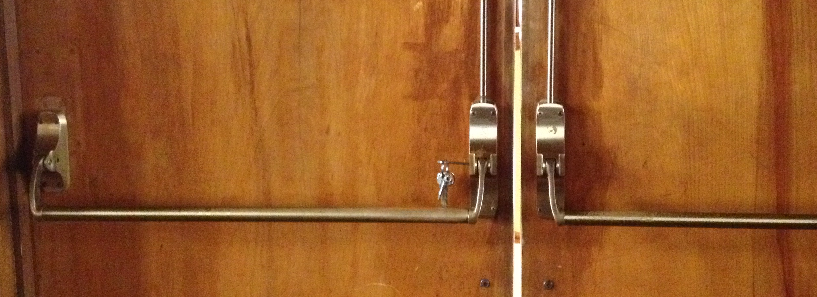

**Balcony**

* We encourage guests to sit in the orchestra level, but some may want to sit in the balcony to take photos, for a better view, etc.
* The balcony doors do not open from the outside. You have to go up to the balcony from the stage and open them from the inside, and they must be propped open to be used.
* Only allow guests to go into the balcony before the concert and during intermission. Remind them that they cannot enter the balcony when those doors are closed and they will not be able to re-enter after exiting.
* If the balcony doors are opened for a concert, make sure you close them completely before you leave the auditorium
* If balcony doors are open, people in the auditorium can hear what happens on the stairs and in the lobby area

**Stage set up**

* Chairs and stands are available backstage on the racks
* If additional equipment is needed, and you are responsible for setting up the stage, collecting the appropriate items, and bringing them to the auditorium.
* If there is percussion, you may need to open room 400 for the people who will be responsible for moving equipment. Please note – occasionally, 400 will be in use by a group who will be aware that access may be required for the concert set up. Please do the work quickly and quietly to allow them to continue their meeting. The needs of the concert take precedent over any other activities.
* Make sure to remove any unnecessary items from the stage **– there should not be extra chairs, stands, garbage, or any other items**. It should always look cleaned up and beautiful!
* If the setup is already known (via tech services form or other), set up the stage. If not, discuss the set up with the performers when they arrive.
* There may be changes between each piece; so be sure to have a program handy on which to take notes.
* Performance managers should always help, but are not obligated to set up programs requiring more than 15 chairs and stands, more than three percussion instruments, a harp - this is written in the ensemble forms!
* Performance managers cannot turn pages or have other duties during a concert. It is the job of the recitalist to find someone prior to their concert if a page-turner is needed.

**Lighting**

* Lights labeled with grey tape stay on during a concert, and all others are off for standard lighting.Discuss the lighting needs with the performer upon arrival.
* The switches all have labels, oriented to standing in the house, facing the stage. For example—the front, right chandelier means—the chandelier that is closest to the switches, which is also the house-right-most chandelier.
* Flash the under balcony lights to alert the audience that the performance is starting.

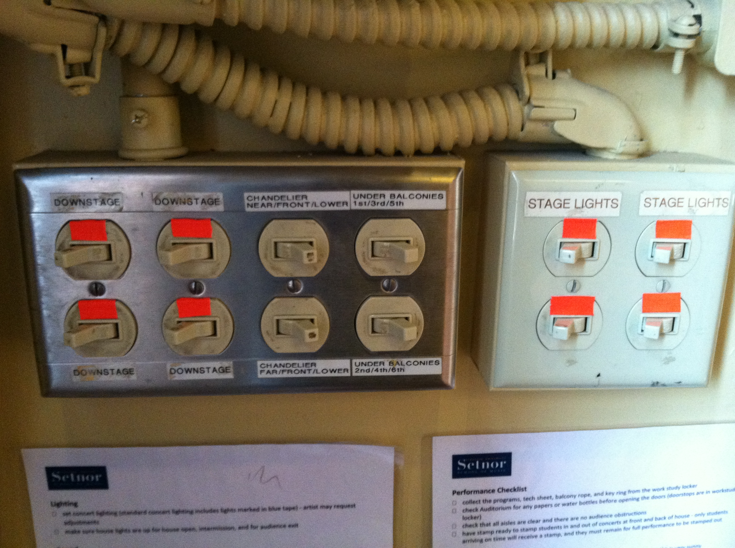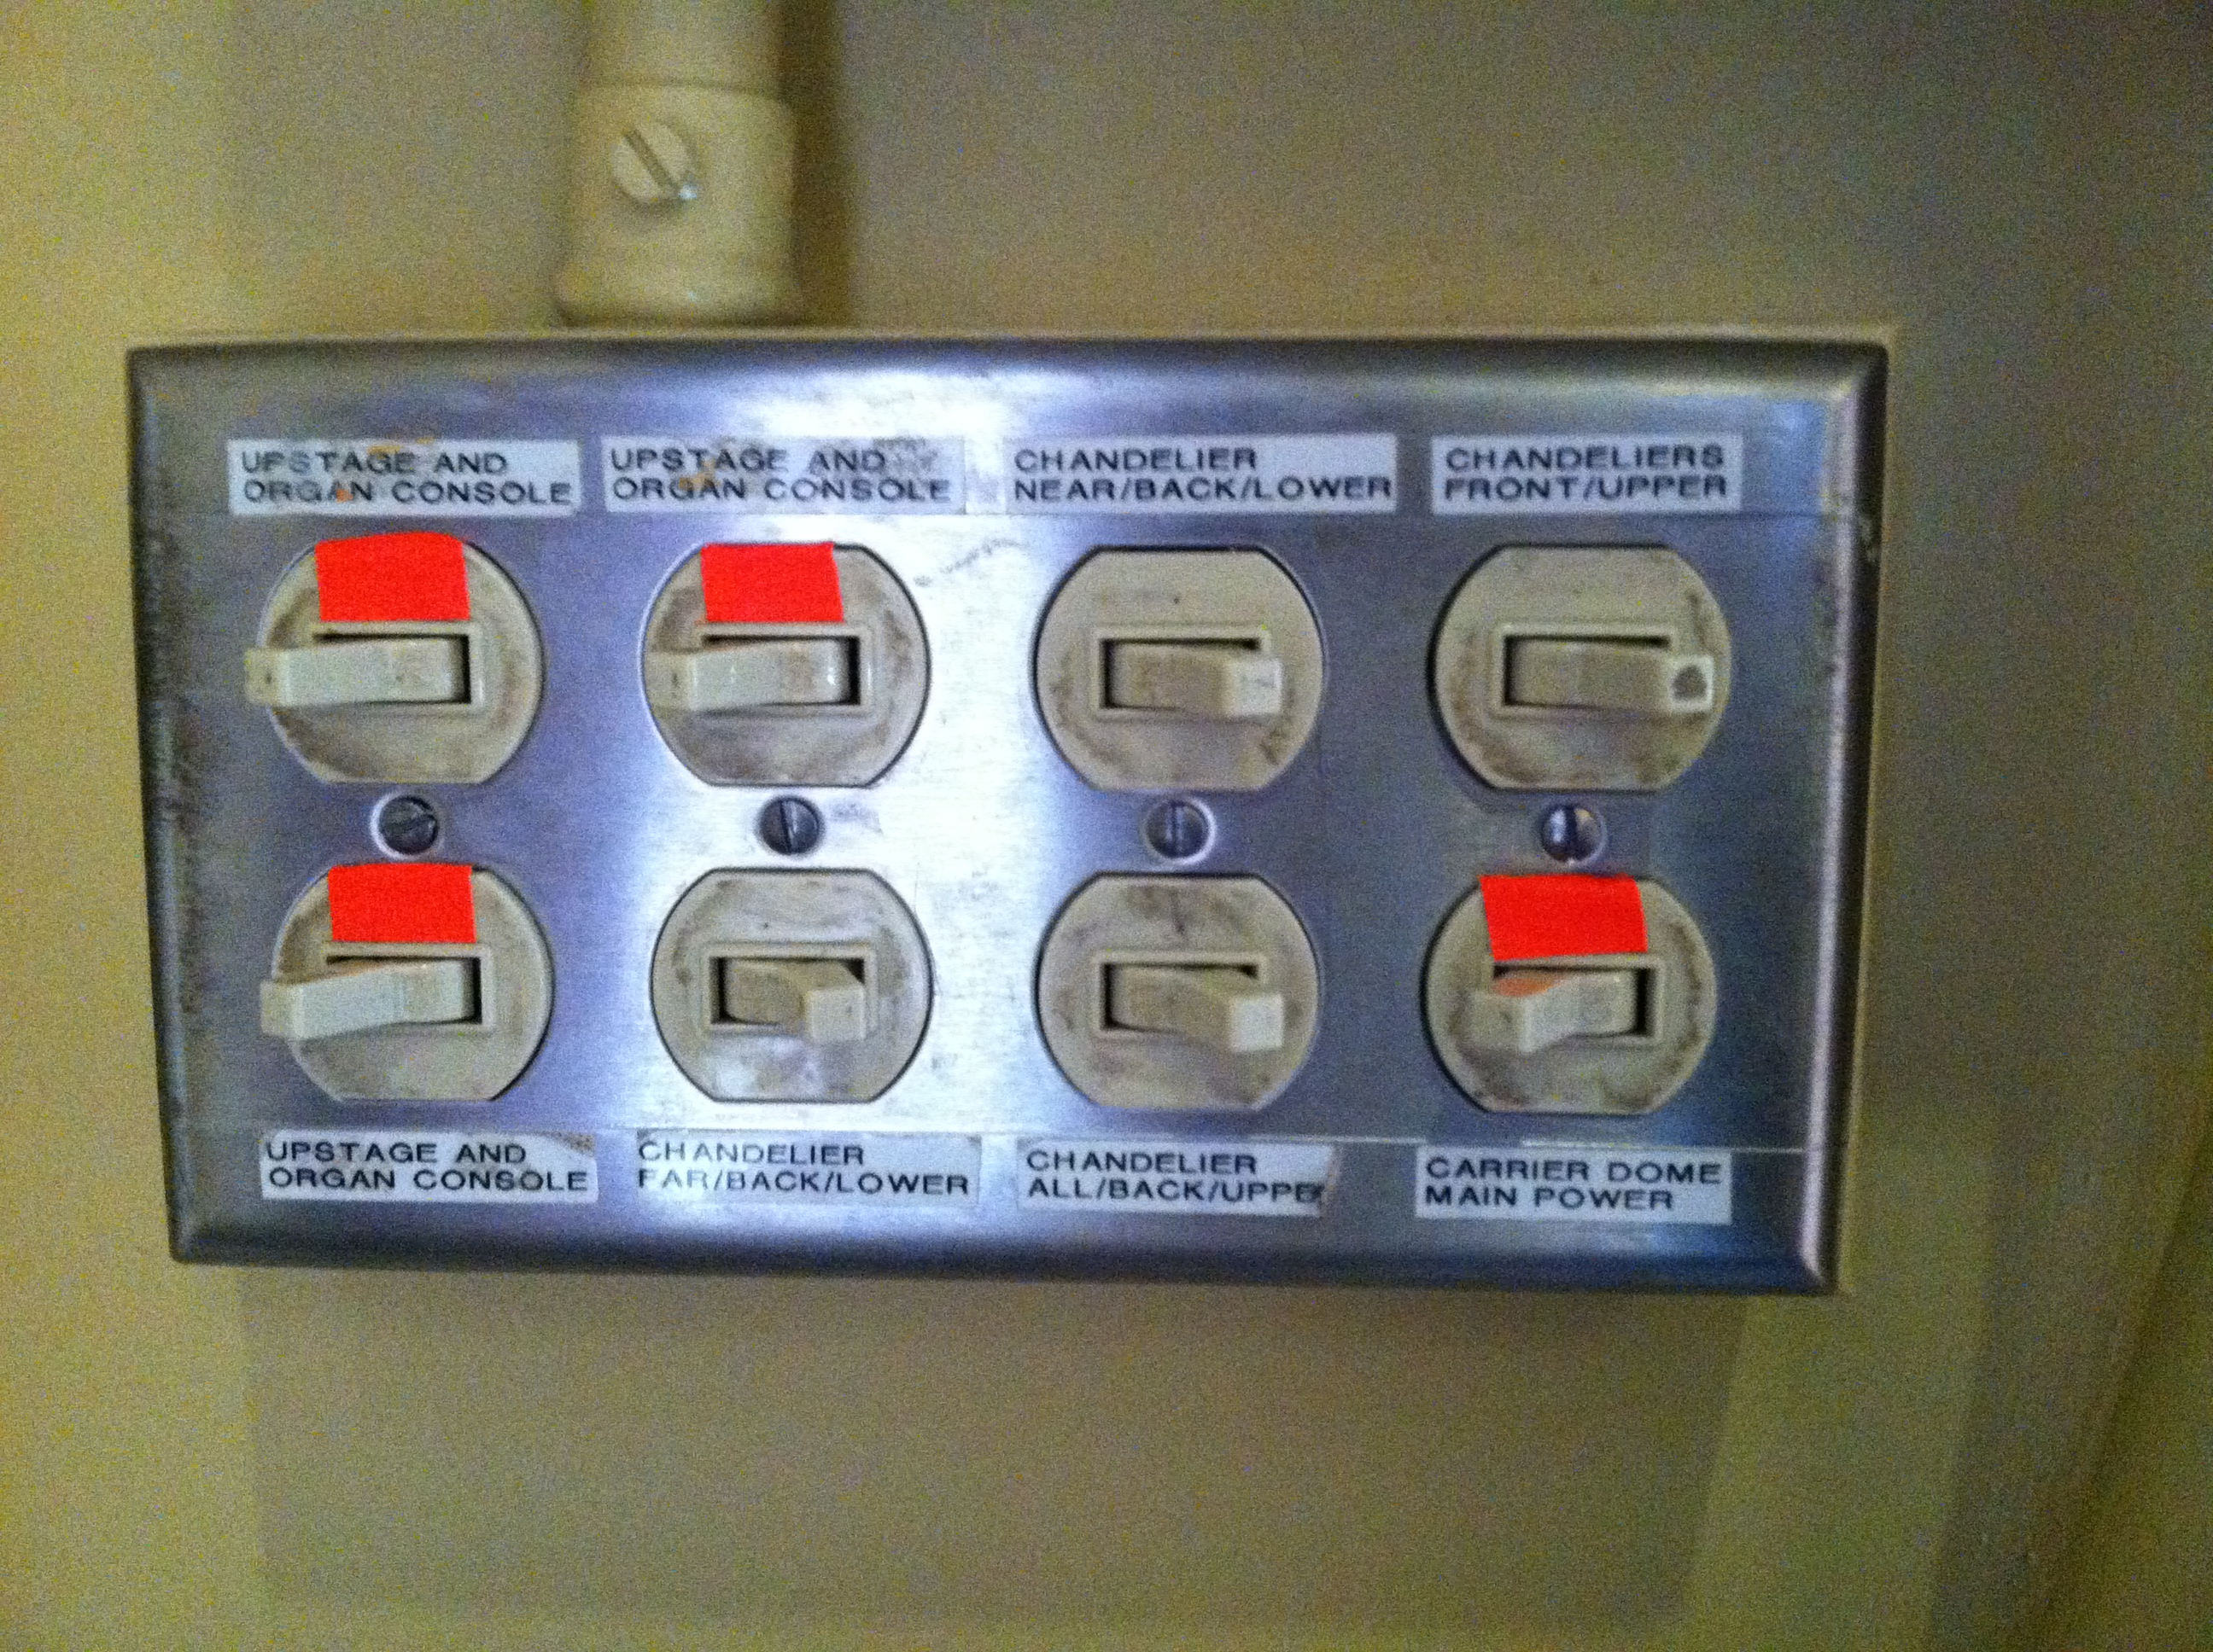

**After Performance Responsibilities**

* Fill out [**Performance Report**](https://its-forms.syr.edu/frevvo/web/tn/SUFS/u/2127254d-3783-447b-8c9d-868cffaeb1ea/app/_L9j2sDxLEeWxmM5q6-jqow/formtype/_ALfdECCNEey8uf3sJN7aAw/popupform?fbclid=IwAR0je1d_rSskrlT11oDW7IE2idrIFbt9pBTxWZobSyprNjs_ldfWjMwkjZ4) and submit.
* Clean up the auditorium - Collect any loose papers, water bottles, etc. and dispose of them, collect any lost items and put them in the lost and found box downstairs (valuables should be stored in 301)
* Cover, lock, and plug in the pianos.
* Close windows. If it is warm, also close shades.
* Break down the stage—return any equipment to backstage, and rack neatly, or allow whoever else is breaking down the stage access to 400 if needed.
* Lock the doors—(remember balcony doors!)
* Turn off the lights.

**Operations locker and operations keys**

* The Operations locker is number 207, found on the top right section of the red lockers outside room 301.
* The keys are to be in the possession of work-study students for concerts only. They must return to the office at the end of each event or shift and placed in the drawer. The keys allow for access to spaces within the building, so it is important that these are secure. If anyone is found to have shared the combination to the locker or given the keys to someone other than a work-study, they will be immediately dismissed.

**Working Convocation:** Working Convocation is similar to working a concert, with a few exceptions:

* Arrive 30 minutes ahead of time to set up for the convocation. You are responsible for set up, set changes and for making sure the Auditorium is back to its original state after Convocation.
* You will need to post attendance QR codes for Convo
* Dress code for Convocation is not as formal as for concerts. All-black is not required unless there is a guest artist. Dress should be appropriate for the event, something in which you are comfortable enough to move equipment and not too casual, as it is still a performance.
* AREA Convo: Occasionally, the professors in charge of area Convos need some help. We ask that everyone assist in their area Convo.

**For JCM events, please note**

* For ensemble concerts, please arrive one hour prior to the start time to assist faculty with items to be moved from Shaffer 201, assist Dr Coggiola as needed, including PowerPoint, bringing down equipment, and helping set up sound equipment.
* For JCM Exposed showcases, assist students in setting up their event
* JCM may set up a livestream the performance, and you can assist the faculty if needed.
* During the performance, assist as needed, and guide audience to seating between numbers.

**Cancelation Check list**

Michelle will usually take care of this. If performance cancels, notify the following contacts*:*

* Director’s office 315-443-5892
* Students scheduled to work the event
* Bob Lee – in case a piano tuning is scheduled
* Recording studio engineer Kevin Muldoon – so he can notify person scheduled for recording 315-730-1982
* Website contact – so message can go on website
* Erica Blust – in case other outlets and press need to be notified [esblust@syr.edu](mailto:esblust@syr.edu)
* Setnor Students, Faculty and Staff via e-mail and Facebook
* Adjust BOSS building system for locking

If building closes or classes are canceled, all work shifts are likely canceled as well. Check with Michelle and Bryan for any questions.

**Performance Checklist – preparing for an event**

* Collect the programs from the racks in 301
* Check Auditorium for any papers or water bottles before opening the doors
* Check that all aisles are clear and there are no obstructions.

**Doors, Windows and Shades**

* Unlock Front and Back of House doors - use the Allen wrench in the operations locker to stop the mechanism on the front-of-house doors from clicking
* Unlock 308 for artist use - lock before concert starts and open for artist at end of concert
* For morning and afternoon concerts, carefully lower balcony shades if needed. For evening concerts, raise shades
* If it is very hot, open windows on both sides of the Auditorium. Close windows after events

**Stage**

* Assist artist with stage set up - check the paperwork and discuss the set up with the performer(s). Larger groups will have their staff/students there for set up.
* Remove unnecessary items from the stage, including stands, chairs, etc.
* Discuss stage changes within program with artist and note on program
* If a group is using risers, this must be arranged in advance to be set by Phi Mu Alpha

**Piano – if needed**

* Move piano into place and check plug in – only move the piano with the lid closed
* Unlock piano keyboard, put bench into place and a chair for a page-turner if needed.
* Adjust the stick to the performer’s preference
* Neatly coil cord and place in nook under piano (it should not show).

**Lighting and Sound**

* Set concert lighting (lights marked in orange tape) - artist may request adjustments
* For larger groups, turn on first row of chandeliers, near stage, so those on the extension are in the light
* Make sure house lights are up for house open, intermission, and for audience exit
* Recording Engineer and tech crew will address. Please assist as needed

**Timings**

* Get timings from artists
* Late seating - ask artist for preference and note between songs, at intermission, during pieces

**Post-concert**

* Collect any loose papers, water bottles, etc. from amongst the seats and dispose of them.
* Break down the stage - return any equipment to backstage or storage classrooms or areas, or allow access to representatives from group for load out
* Lock the doors, including balcony doors
* Turn off the lights
* Place valuable lost and found items, extra programs, and keys to 301.
* Submit performance report
* At this time, receptions cannot be accommodated. Performers may briefly meet with people after their event
* Check that set up in 308 is ready for classes and that performer has not left anything
* Close the windows, turn off the lights and lock the door